**DAY-3 Assignment**

**Name- Dibya Ranjan Rath**

**SIC- 20BCSE62**

**Q)** Create a restaurant page like we created movie page, each box will be having 2 buttons, On clicking one button some description should show and on the same box On clicking other button description should fade away.

**Output:**

(Sample Output-1)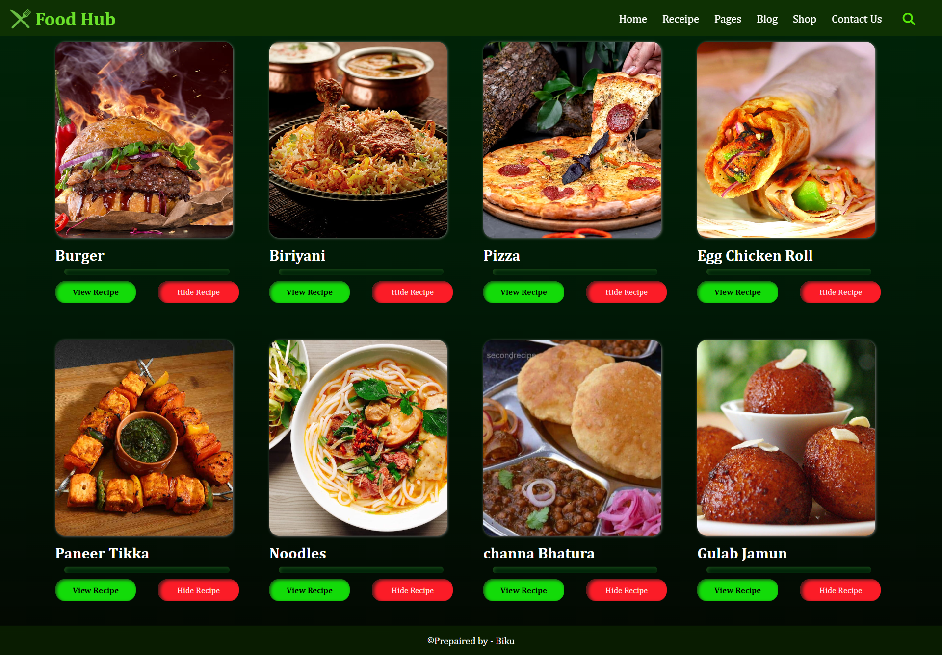

(Sample Output-2)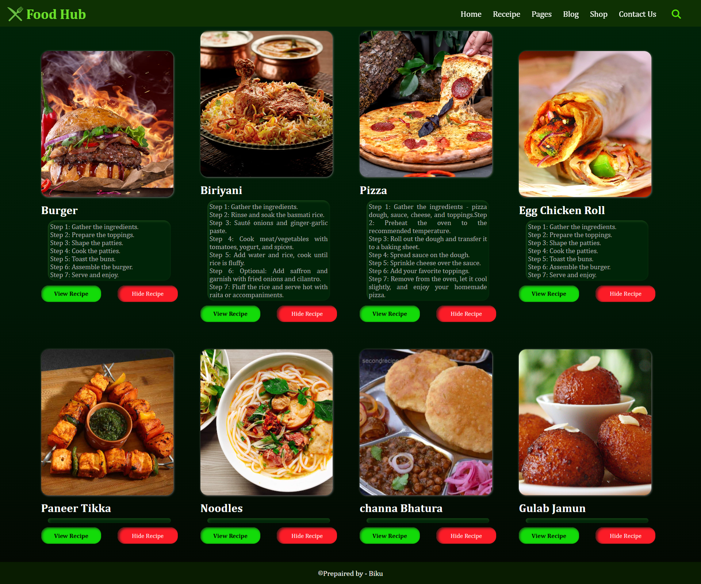

**Code:**

File name- ass3.html

<!DOCTYPE html>

<html lang="en">

<head>

    <meta charset="UTF-8">

    <meta http-equiv="X-UA-Compatible" content="IE=edge">

    <meta name="viewport" content="width=device-width, initial-scale=1.0">

    <title>Know your Food Receipe</title>

    <link rel="stylesheet" href="https://cdnjs.cloudflare.com/ajax/libs/font-awesome/6.4.0/css/all.min.css"  />

    <link rel="stylesheet" href="ass3.css">

</head>

<body>

    <div class ="navbar">

            <img id="Logo" src="image/fork-knife.png" alt="Netflix" height="35px"><h1 id="logo_Text">Food Hub</h1>

            <div class="nav_text" style=" margin-left: 51rem;">Home</div>

            <div class="nav_text">Receipe</div>

            <div class="nav_text">Pages</div>

            <div class="nav_text">Blog</div>

            <div class="nav_text">Shop</div>

            <div class="nav_text">Contact Us</div>

        <div class="right">

            <i class="fa-solid fa-magnifying-glass" style="color: #58eb09;"></i>

        </div>

    </div>

    <div id="food"></div>

    <footer class="nav-bg">

        <p class="text-footer">

            <sup>©</sup>Prepaired by - Biku

          </p>

    </footer>

</body>

<script src="ass3.js"></script>

</html>

File name- ass3.css

*{

    margin: 0;

    padding: 0;

    box-sizing: border-box;

    font-family:Cambria, Cochin, Georgia, Times, 'Times New Roman', serif;

}

body{

    background: linear-gradient(to top ,#030802,#011806,#002408);

    background-attachment: fixed;

}

.navbar{

    display: flex;

    background-color: #123601c3;

    position: sticky;

    top: 0;

    left: 0;

    right: 0;

    width: 100%;

    z-index: 1;

    height: 58px;

}

.nav_text{

    color: #fff;

    padding: 20px;

    padding-left: 0.3rem;

    font-size: 18px;

    cursor: pointer;

    font-weight: 400;

}

.nav_text:hover{

    font-size: 20px;

    font-weight: 400;

    color: #6ae12a;

    text-shadow: 0px 0px 1px #ff8484;

    transition: 0.25s;

}

#Logo{

    margin-top: 0.8rem;

    margin-left: 1rem;

}

#logo_Text{

    margin-top: 0.8rem;

    margin-left: 0.4rem;

    color: #6ae12a;

     font-size: 30px;

     font-weight: 600;

}

.right{

    margin-left: 92rem;

    position: fixed;

    margin-top: 1.2rem;

    color: #fff;

    font-size: 20px;

    font-weight: 700;

    cursor: pointer;

}

#food{

    align-items: center;

    justify-content: center;

    padding-left: 90px;

    padding-right: 70px;

    padding-top: 10px;

    display: grid;

    grid-template-columns: repeat(4,1fr);

    gap: 20px;

}

#food img{

    width: 290px;

    height: 320px;

    object-fit: cover;

    border-radius: 1rem;

    box-shadow: 1px 1px 4px #807d7d;

}

#food h3{

    margin-top: 10px;

    font-size: 25px;

    font-weight: 700;

    color: #fff;

}

#food p{

    margin-right: 45px;

    margin-top: 8px;

    font-size: 15px;

    font-weight: 500;

    color: #aeaeae;

    text-align:justify;

    background: #002408;

    padding: 5px;

    margin-left: 15px;

    box-shadow:inset 2px 2px 5px #1b4918;

    border-radius: 1rem;

 }

 .view_button, .remove_button{

    margin-top: 10px;

    margin-bottom: 40px;

    width: 40%;

    border-radius: 1rem;

    border: none;

    cursor: pointer;

    padding: 10px;

 }

 .view_button{

    box-shadow:inset 2px 2px 5px #1b4918;

    font-weight: 600;

    margin-right: 11%;

    background-color: #13db09;

    color: #000000;

 }

 button:hover{

    background-color: #5858f0;

    color: #000000;

    transition: 0.4s;

 }

 .remove_button{

    /* margin-left: 20%; */

    font-weight: 400;

    background-color: #fb1c27;

    box-shadow: inset 4px 2px 5px #4e1a1a;

    color: #ffe9e9;

 }

  .nav-bg {

      background: #0c2700a3;

      background-size: cover;

    }

    .text-footer {

      text-align: center;

      padding: 15px 0;

      display: flex;

      justify-content: center;

      color: white;

    }

File name- ass3.js

const data=[

{

    image: "https://e0.pxfuel.com/wallpapers/227/1006/desktop-wallpaper-burger-sandwich-food-fire.jpg",

    foodName: "Burger",

    recipe: "Step 1: Gather the ingredients.\nStep 2: Prepare the toppings.\nStep 3: Shape the patties.\nStep 4: Cook the patties.\nStep 5: Toast the buns.\nStep 6: Assemble the burger.\nStep 7: Serve and enjoy.",

},

{

    image: "https://e0.pxfuel.com/wallpapers/656/834/desktop-wallpaper-craving-biryani-head-over-to-these-delectable-spots-in-mumbai-biriyani.jpg",

    foodName: "Biriyani",

    recipe: "Step 1: Gather the ingredients.\nStep 2: Rinse and soak the basmati rice.\nStep 3: Sauté onions and ginger-garlic paste.\nStep 4: Cook meat/vegetables with tomatoes, yogurt, and spices.\nStep 5: Add water and rice, cook until rice is fluffy.\nStep 6: Optional: Add saffron and garnish with fried onions and cilantro.\nStep 7: Fluff the rice and serve hot with raita or accompaniments.",

},

{

    image: "https://e0.pxfuel.com/wallpapers/256/32/desktop-wallpaper-delicious-pizza-food.jpg",

    foodName: "Pizza",

    recipe: "Step 1: Gather the ingredients - pizza dough, sauce, cheese, and toppings.Step 2: Preheat the oven to the recommended temperature.\nStep 3: Roll out the dough and transfer it to a baking sheet.\nStep 4: Spread sauce on the dough.\nStep 5: Sprinkle cheese over the sauce.\nStep 6: Add your favorite toppings.\nStep 7: Remove from the oven, let it cool slightly, and enjoy your homemade pizza.",

},

{

    image: "https://e1.pxfuel.com/desktop-wallpaper/883/921/desktop-wallpaper-indian-food-india-and-mobile-backgrounds-egg-roll.jpg",

    foodName: "Egg Chicken Roll",

    recipe: "Step 1: Gather the ingredients.\nStep 2: Prepare the toppings.\nStep 3: Shape the patties.\nStep 4: Cook the patties.\nStep 5: Toast the buns.\nStep 6: Assemble the burger.\nStep 7: Serve and enjoy.",

},

{

    image: "https://geekrobocook.com/wp-content/uploads/2021/03/6.-Paneer-Tikka.jpg",

    foodName: "Paneer Tikka",

    recipe: "Step 1: Gather the ingredients.\nStep 2: Prepare the toppings.\nStep 3: Shape the patties.\nStep 4: Cook the patties.\nStep 5: Toast the buns.\nStep 6: Assemble the burger.\nStep 7: Serve and enjoy.",

},

{

    image: "https://images.pexels.com/photos/2664216/pexels-photo-2664216.jpeg?auto=compress&cs=tinysrgb&w=1260&h=750&dpr=1",

    foodName: "Noodles",

    recipe: "Step 1: Gather the ingredients.\nStep 2: Prepare the toppings.\nStep 3: Shape the patties.\nStep 4: Cook the patties.\nStep 5: Toast the buns.\nStep 6: Assemble the burger.\nStep 7: Serve and enjoy.",

},

{

    image: "https://www.secondrecipe.com/wp-content/uploads/2016/04/channa-bhatura-540x720.jpg",

    foodName: "channa Bhatura",

    recipe: "Step 1: Gather the ingredients.\nStep 2: Prepare the toppings.\nStep 3: Shape the patties.\nStep 4: Cook the patties.\nStep 5: Toast the buns.\nStep 6: Assemble the burger.\nStep 7: Serve and enjoy.",

},

{

    image: "https://e1.pxfuel.com/desktop-wallpaper/482/834/desktop-wallpaper-gulab-jamun-in-india-gulab-jamun.jpg",

    foodName: "Gulab Jamun",

    recipe: "Step 1: Gather the ingredients.\nStep 2: Prepare the toppings.\nStep 3: Shape the patties.\nStep 4: Cook the patties.\nStep 5: Toast the buns.\nStep 6: Assemble the burger.\nStep 7: Serve and enjoy.",

},

];

const Food= document.getElementById("food");

data.map((el)=>{

    const div=document.createElement("div");

    const img=document.createElement("img");

    img.src=el.image;  //This image is which we declare in the data

    const food_Name = document.createElement("h3");

    food_Name.innerText = el.foodName;  //This title is which we declare in the data

    const Recipe = document.createElement("p");

    Recipe.innerText = "";

    const button1 =document.createElement("button");

    button1.classList.add("view_button");

    const button2 =document.createElement("button");

    button2.classList.add("remove_button");

    button1.innerText = "View Recipe";

    button2.innerText = "Hide Recipe";

    button1.addEventListener("click",()=>{

        Recipe.innerText=el.recipe;

    }),

    button2.addEventListener("click",() =>{

        Recipe.innerText="";

    });

    div.append(img, food_Name, Recipe,button1,button2);

    Food.append(div);

}

);

____x____